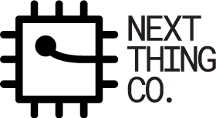

Get Started With PocketC.H.I.P.
What is PocketC.H.I.P.?
Power
Turn On
Sleep
Shutdown
Battery Life
Charging
Setup WiFi
Adjust Brightness and Volume
Flash Software
Display
Keyboard
Removable Enclosure
Pencil/Pen Stand
Applications
Terminal
PICO-8
SunVox
Help
Write
File Browser

What is PocketC.H.I.P.?
Simply put, PocketC.H.I.P. is a small computer. It has all the parts of a computer like a screen (touchscreen!), keyboard and USB port to connect a mouse to. What makes PocketC.H.I.P. unique from other computers is not only its size but the fact it was created to be hacked and used as an educational tool.

A popular way to teach with PocketC.H.I.P. is for students to learn basic programming and game design principles while playing them in the fantasy console Pico-8. They can hack existing video games or create their very own game from scratch.

PocketC.H.I.P. has a lot more to offer since it’s powered by C.H.I.P., the world’s first $9 computer. Some other things students can learn are how to use a command-line interface using the Terminal app to create and organize files and directories. Sensors and LEDs can be connected to PocketC.H.I.P.’s GPIOs and programmed using the Python language to gather data and actuate.

Just like any computer PocketC.H.I.P. has specs which are defined by the fact it runs on C.H.I.P..

Processor | ARM Cortex-A8 32-bit
Architecture | ARMv7-A
GPU | Mali 400 (400MHz)
RAM | 512 MB
Storage | 4 GB NAND Flash
Network | WiFi 802.11n / Bluetooth 4.0
GPIO | 53

In this guide you will be introduced to the basic functionalities of PocketC.H.I.P. and be introduced to the applications it comes with out of the box.

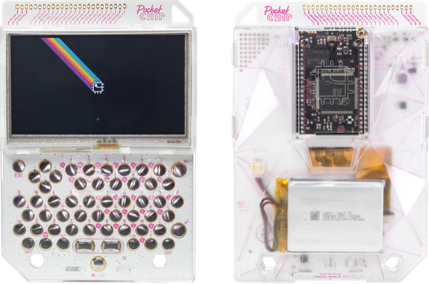

Power

Turn On
Turn on PocketC.H.I.P. by pressing down the Home/Power button located at the bottom in the middle of the keyboard for about two seconds.

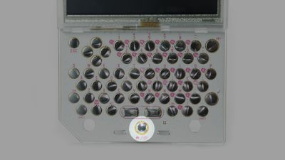

Sleep
Once PocketC.H.I.P. is powered on it can be put in sleep mode and powered down safely by tapping on the power icon in the lower left corner of the home screen and choosing an option from the power menu.

Power icon:


Power Menu:
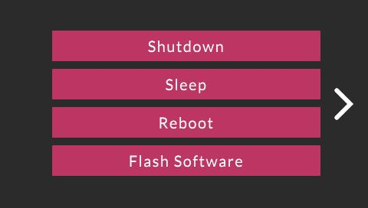

Sleep is a low-power state that saves battery, and also saves you time, since it's faster for PocketC.H.I.P. to wake from sleep than to boot from a powered-off state.

PocketC.H.I.P. is designed to turn off the screen and backlight after a few minutes without any user interaction. To wake up PocketC.H.I.P. from sleep state, simply touch the screen or press a key.

Shutdown
Shutdown PocketC.H.I.P. by pressing the power icon in the bottom left corner of the home screen and tapping “Shutdown” .

If PocketC.H.I.P. becomes unresponsive, hold down the Home/Power button for eight seconds. This cuts battery power to PocketC.H.I.P. and shuts it off. Only use this method if all other methods do not work.

Battery Life
PocketC.H.I.P. lasts for about 5 hours of use with a fully charged battery.

How to preserve battery life:
- Dim screen brightness
- Turn off WiFi

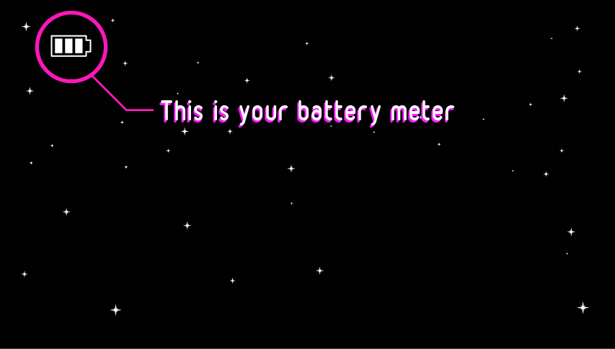

Charging
Plug PocketC.H.I.P. into a 5-volt 1.5 Amp power supply with a USB-micro cable to charge the 3.7V battery. PocketC.H.I.P. is compatible with most cell phone chargers that use a USB-micro cable.

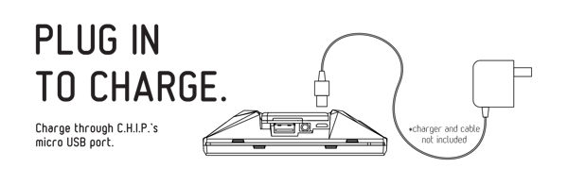

Setup WiFi

A WiFi connection isn’t necessary for PocketCHIP to operate. It’s useful when updating and installing software packages and for exploring community made games while using the Pico-8 application.

To connect to a WiFi network tap the settings icon to access the Settings screen.

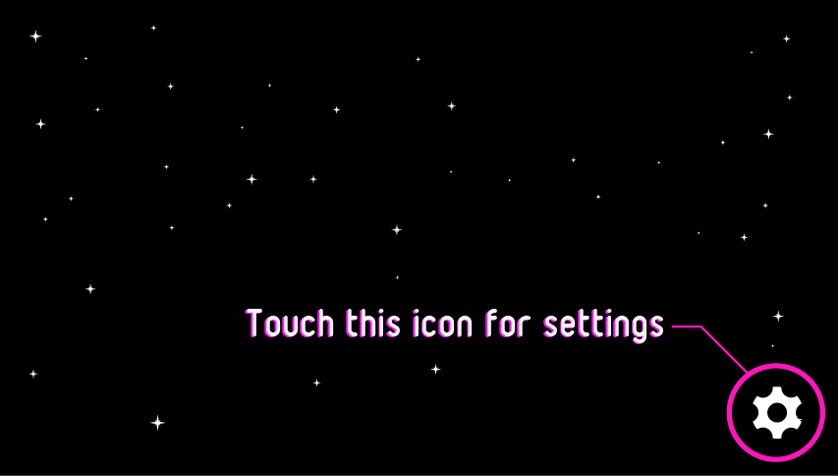
Press the button to the right of the WiFi toggle switch to open a menu of all the networks in range.
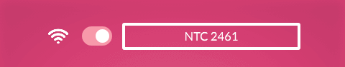
Scroll through the list and select your network by pressing the arrows above and below the network names. To refresh the network list, just exit the list and enter again. When prompted, enter the network password in the text field, then touch the Connect button. It may take a few seconds to connect.

Adjust Brightness and Volume
Adjust the screen’s brightness and the volume level of the headphone output by dragging the sliders on the Settings screen. Drag right to increase brightness and volume.
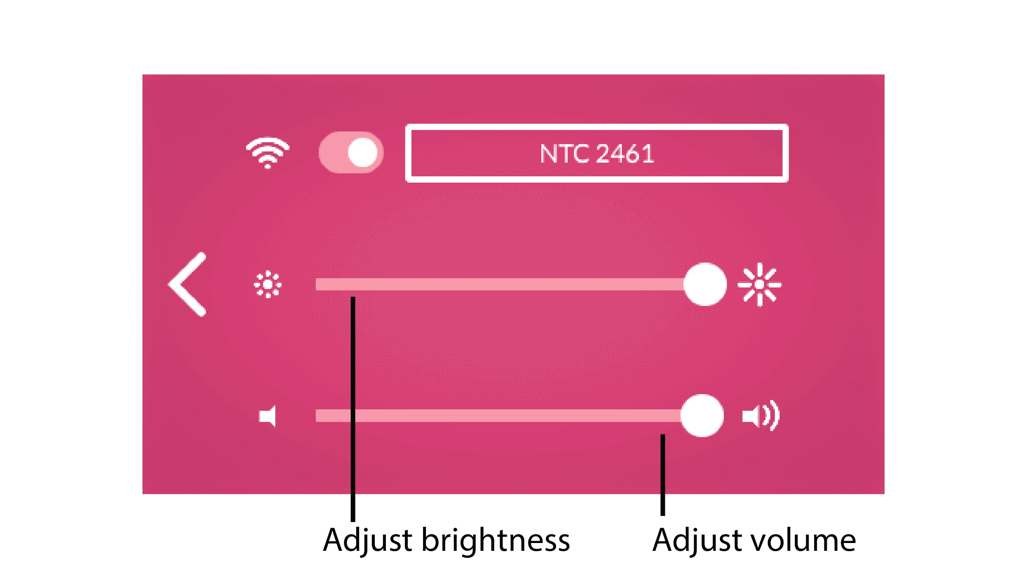

Flash Software
PocketC.H.I.P. already comes flashed with the latest software out of the box and is ready to go.

You do not need to flash PocketC.H.I.P. unless you want to roll back to a previous version of the operating system or if you find C.H.I.P. frozen and inoperable. To flash PocketC.H.I.P., take C.H.I.P. out and flash it independently. To flash it with the latest factory image follow the Flash C.H.I.P. With an OS instructions on the C.H.I.P. doc page.

WARNING: Flashing will permanently delete all the data on PocketC.H.I.P., so backup anything you want to keep before doing so.

Display
Size: 4.3”
Resolution: 480 x 272
Type: resistive touch

To easily navigate the touch screen the eraser of a pencil or a commercial stylus comes in handy rather than using your finger. In the classroom the pencil becomes particularly useful and it doubles as a stand!

Supported actions:
- Tap once to open apps, press buttons, and close windows.
- Press and slide to scroll, adjust sliders, and resize windows.

Keyboard
PocketC.H.I.P. has a full QWERTY keyboard and a D-pad for gaming.

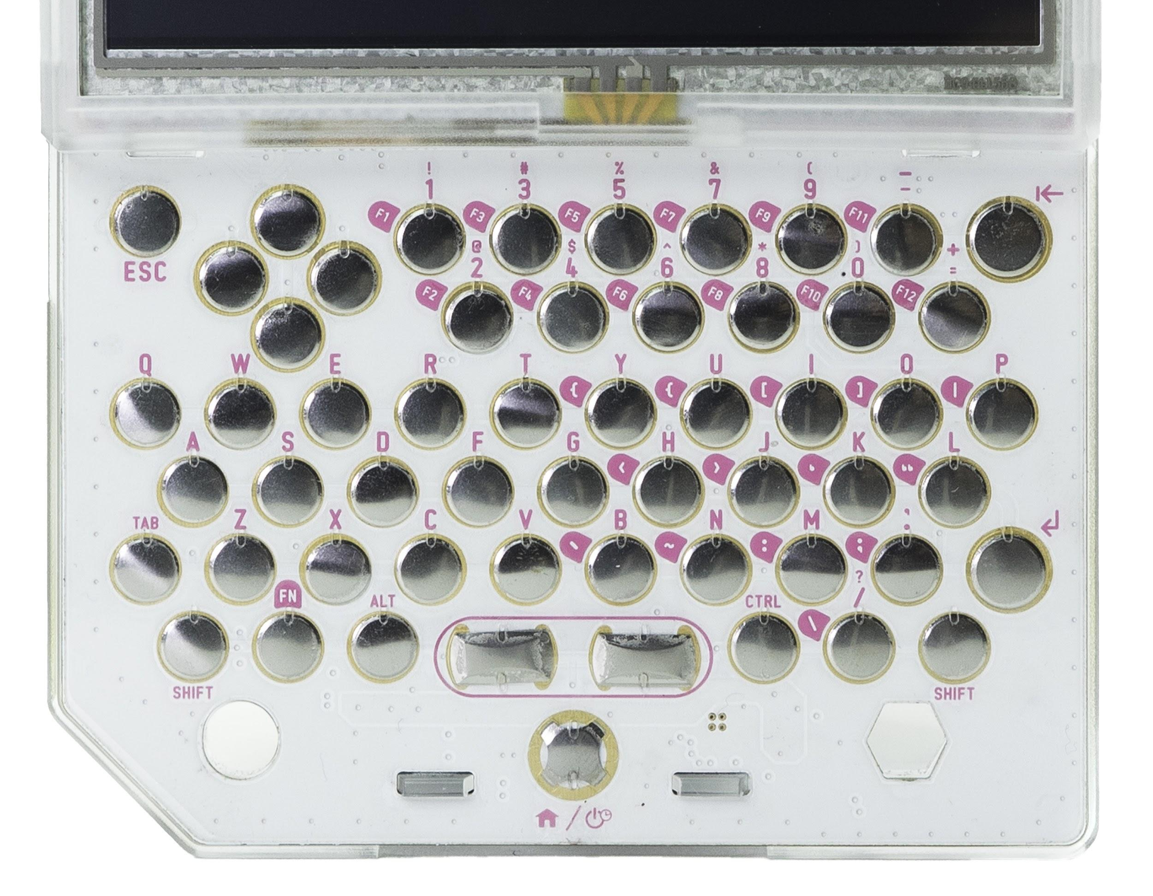

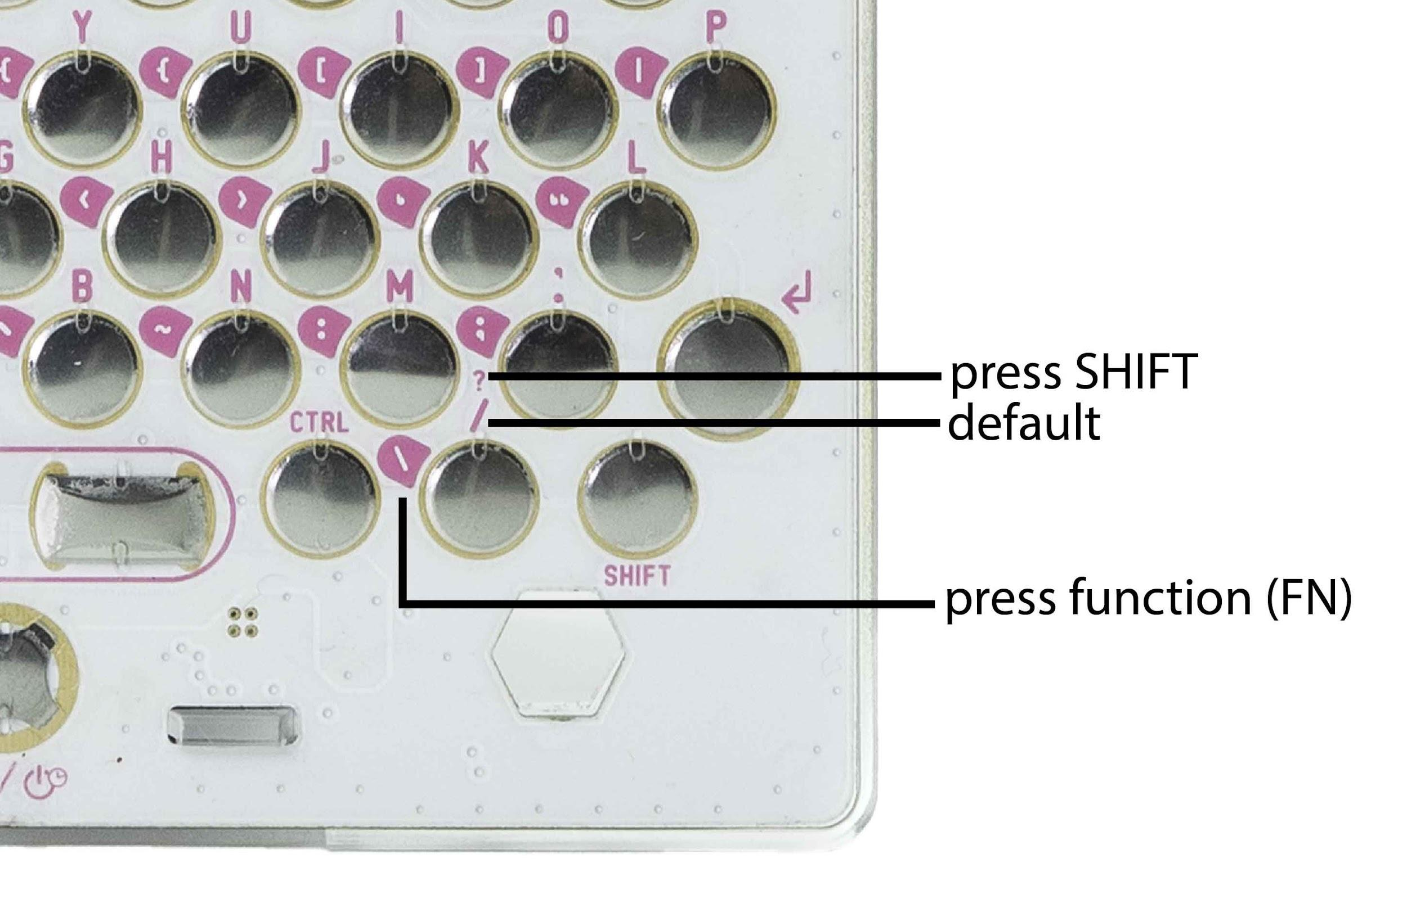

Many keys have multiple functions which are printed on the keyboard. Here is how to access each character:
- Top character - Press Shift + [key]
- Bottom character - Default character
- White text on pink - Press FN (function) + [key]

Helpful keyboard shortcuts:
- CTRL + TAB - Scroll through application windows when multiple are open.
- CTRL + Q - Quit an application

Removable Enclosure

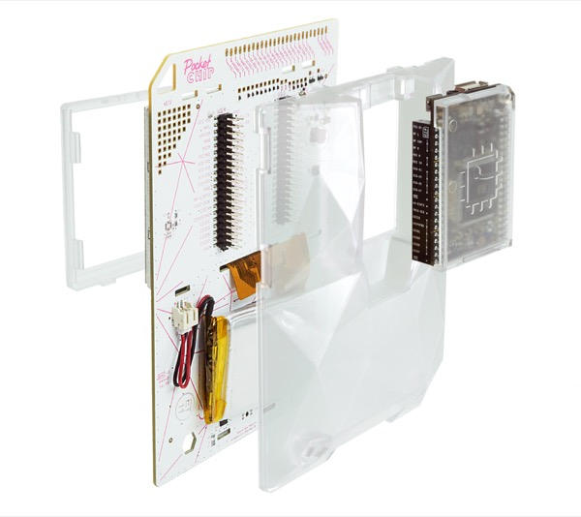

PocketC.H.I.P. is designed to be easily taken apart since there are no screws used in the assembly.

If you want to fully disassemble PocketC.H.I.P., first (carefully) remove C.H.I.P. from the back of PocketC.H.I.P.. Then flip PocketC.H.I.P. around and remove the frame (technically known as a bezel) around the perimeter of the screen. Remove the back case of PocketC.H.I.P. by pressing the tabs above the screen and on either side of the Home/Power button.
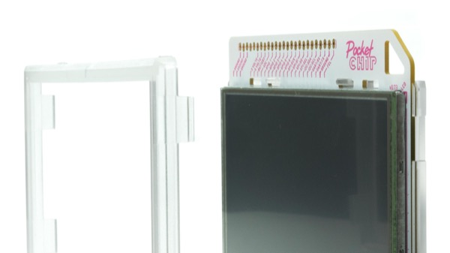

While the case is open, check out the “secret” prototyping area and GPIO solder pads inside the enclosure!
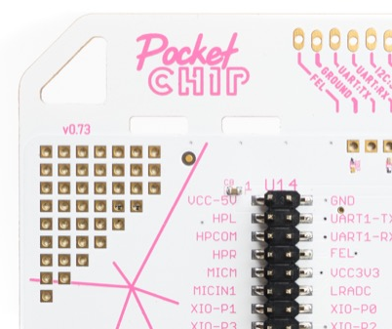

Pencil/Pen Stand
Give your hands a break! PocketC.H.I.P. can be propped up on a table with a pencil or pen. The eraser end of a pencil is also a handy stylus for the touch screen.
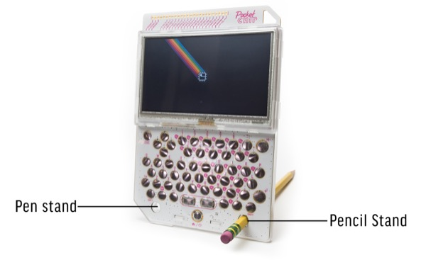

Applications
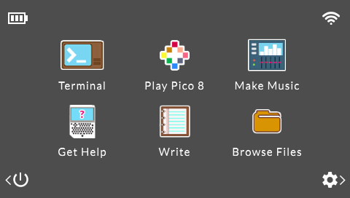

PocketC.H.I.P. comes with six applications on the Home Screen.

- PICO-8 - play, create, share 8-bit games
- SUNVOX - listen or compose electronic music
- Terminal - use a Linux shell to run commands
- Write - a lightweight text editor
- File Browser - a graphical file browser
- Help - the same as the online documentation, built into PocketC.H.I.P.

Terminal
Terminal is a place to type commands directly to the computer for execution and evaluation by the operating system. There are no icons, just text.

Terminal on PocketC.H.I.P. can be an excellent tool to teach students about the power of a computer’s command-line interface.

Use the terminal to dive into the operating system’s guts, quickly move files around, play with PocketC.H.I.P.'s GPIO, or download software. To learn more, check out the primer on using Terminal in the C.H.I.P. documentation.

Terminal toolbar:
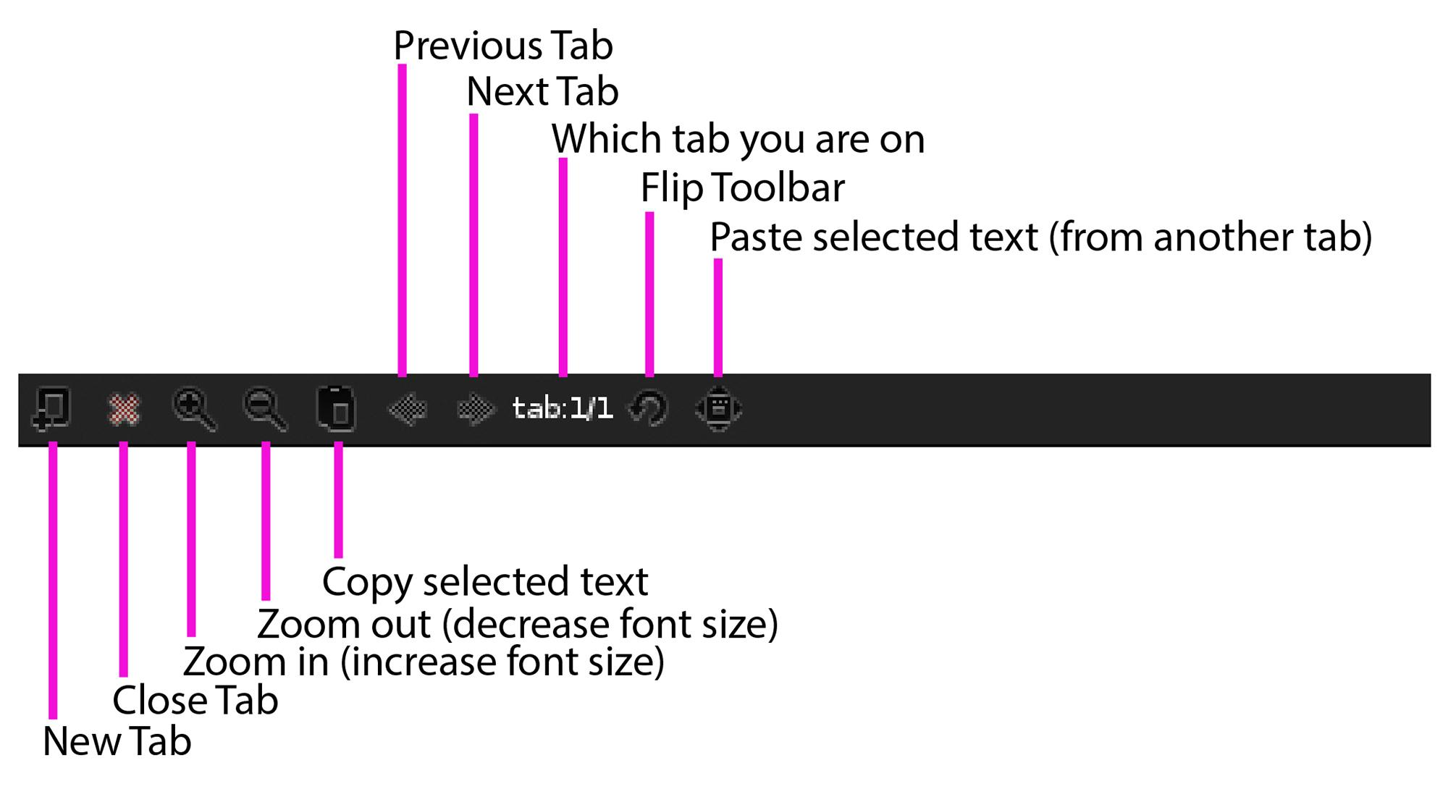

PICO-8
Play games, change games, and make games with PICO-8! With a couple of keystrokes you can join the PICO-8 community and modify their games, or even make your own! This application is very popular in an educational setting. Students learn how to program while hacking existing games and creating their own.

SunVox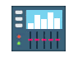
The SunVox tracker is a fully featured music production studio. It's lightweight, sounds great, and is designed to work with a stylus on a single, small screen. As a result, it's a perfect fit for for making music and playing with sound on PocketC.H.I.P.. Learn more about how to use SunVox by tapping the Help icon or by going to PocketC.H.I.P.’s online documentation.

Help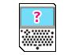
Tapping this icon will take you to the full Help document which is the same as the PocketC.H.I.P. doc page found online.

Write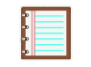
Write is a minimalist text editor that's well suited for basic text entry tasks. If you're looking to scribe code with Write, you'll be pleased to learn that it supports line numbering and auto indentation, just look under the “Option” menu.

File Browser
The File Browser provides a visual representation of the files on PocketC.H.I.P. using icons. Drag, drop, and double-click your way through this application for full control over every file on your device.

PocketC.H.I.P. Resources
PocketC.H.I.P. Online Docs

